**Lab5 HBase with Docker**

**Step1: make sure docker/docker-compose are installed**

If you have installed docker in your system, skip this step.

After you see something just as follow, you need to be patient to wait some minutes.

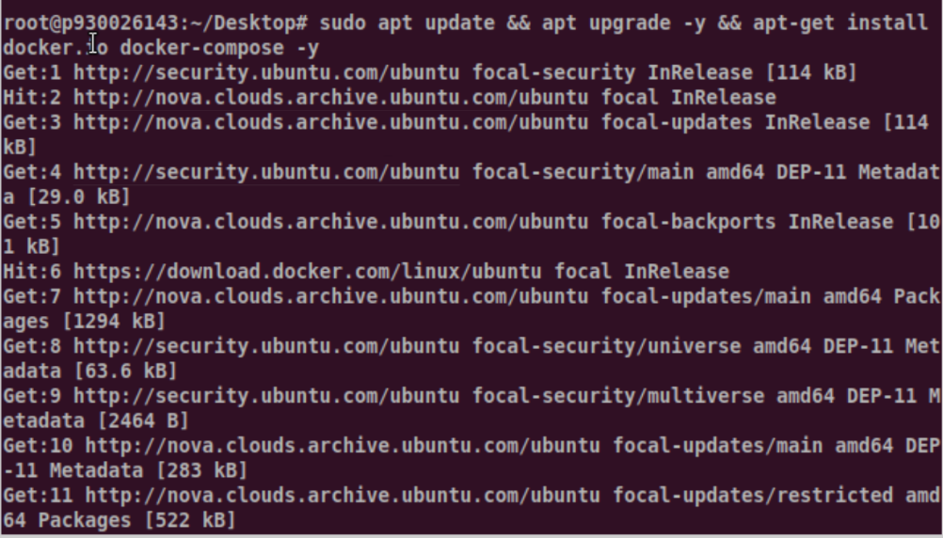

Then install docker-compose this command:

you may encounter some errors:

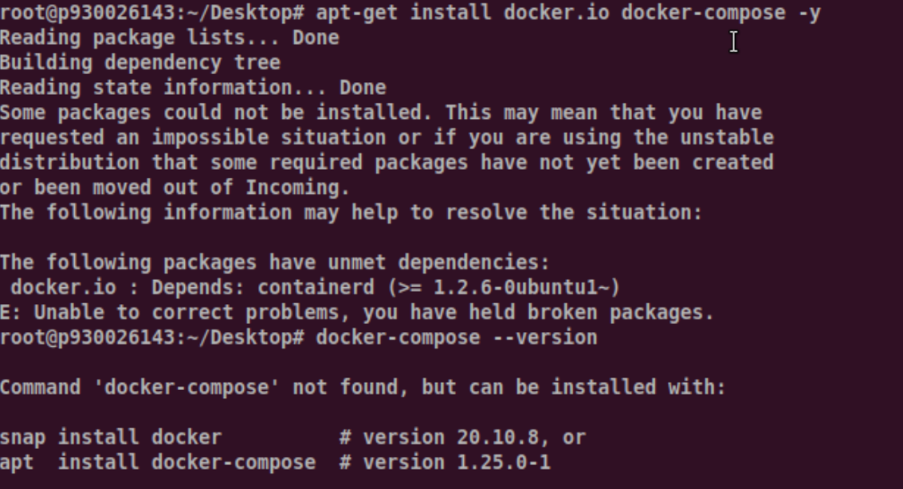

To check the version of your Docker Engine, and Compose, use the following commands:

- and -–

It will be like as follow. Docker has installed successful but fail to install docker-compose.





Then we can solve this problem by this command:

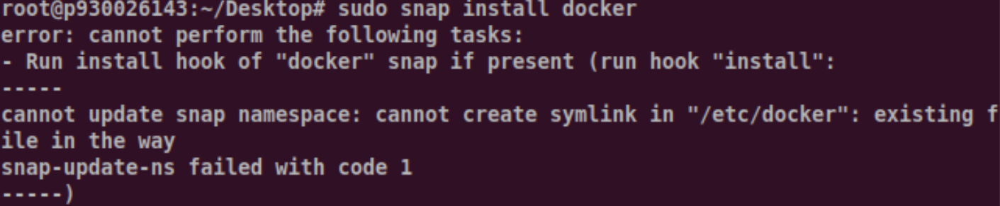

After that, you will find that you can install docker-compose by apt.

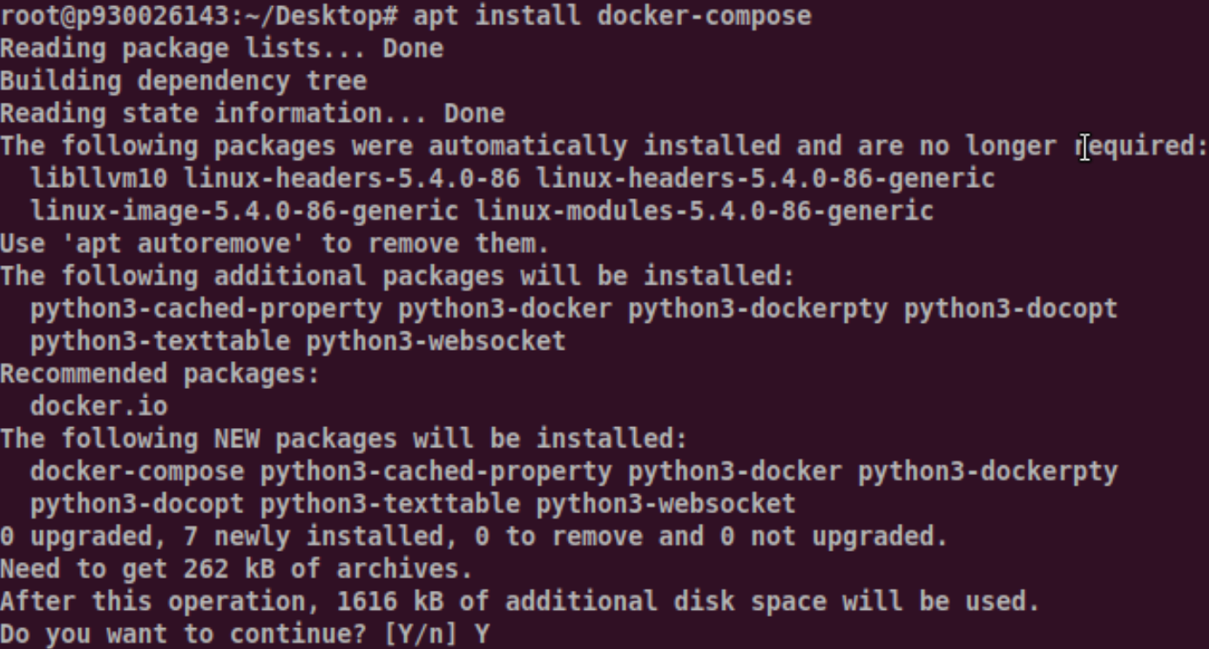

Then check the version of your Docker Engine, and Compose again:

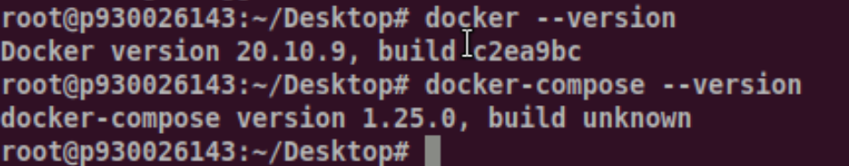

When you can get this information, you can successfully install them.

**Step 2: clone the docker-hbase project**

You need to download/clone the project from the gitbub.

Type the following command to clone the docker-hbase project

---

Suppose the docker-hbase is cloned/downloaded to your home directory or you can define a directory to store it. Then enter to the document page: -

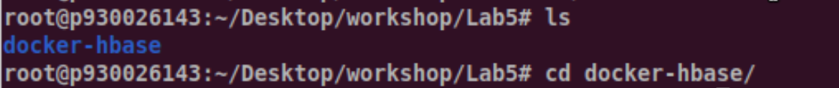

Then to deploy an example standalone HBase cluster, run:

----

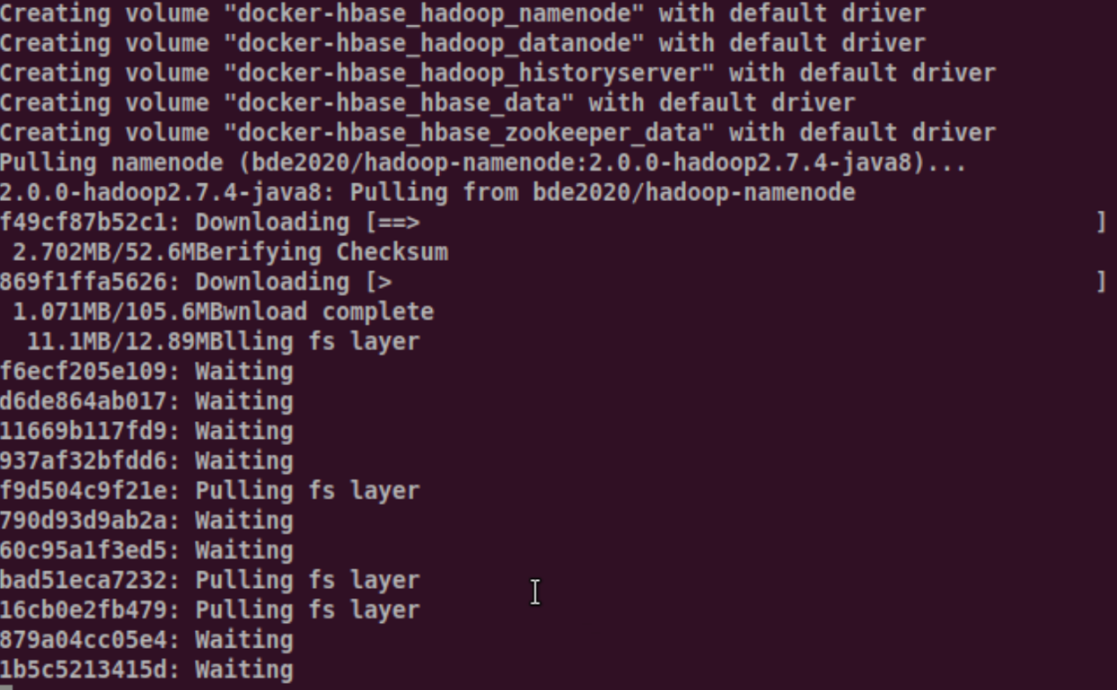

It may take you several minutes and please wait patiently.

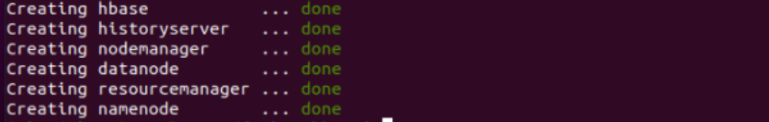

**Step 3:**

Then after finishing, you can enter the hbase contain by executing command: -



**Step4:**1. Connect to HBase.

Connect to your running instance of HBase using the command, located in the bin/ directory of your HBase install. In this example, some usage and version information that is printed when you start HBase Shell has been omitted. The HBase Shell prompt ends with a > character.

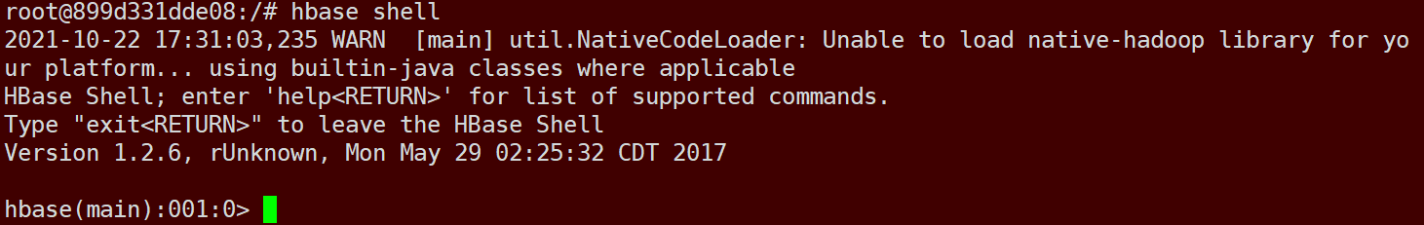

2. Display HBase Shell Help Text.

Type help and press Enter, to display some basic usage information for HBase Shell, as well as several example commands. Notice that table names, rows, columns all must be enclosed in quote characters.

3. Create a table.

Use the create command to create a new table. You must specify the table name and the name.

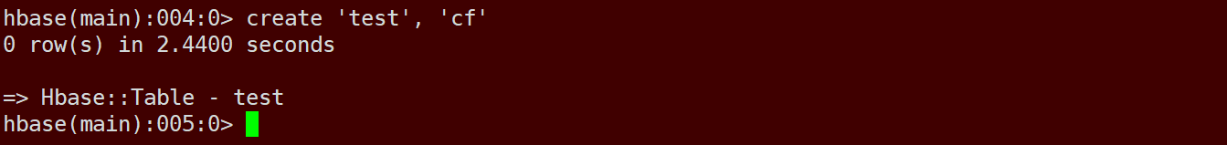

The “test” is the table and the “” is the name.



4. List Information About your Table

Use the list command to confirm your table exists

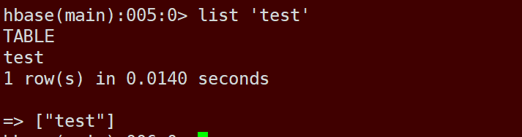

Now use the describe command to see details, including configuration defaults.

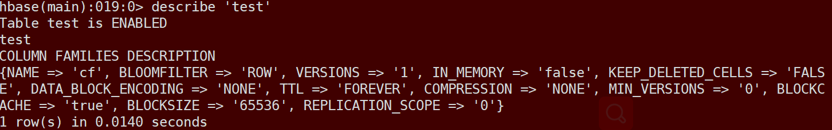

5. Put data into your table.

To put data into your table, use the put command.

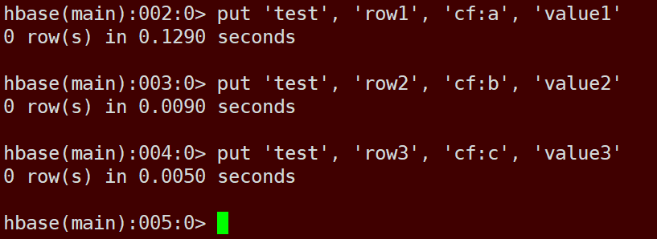

Here, we insert three values, one at a time. The first insert is at row1, column cf:a, with a value of value1. Columns in HBase are comprised of a column family prefix, cf in this example, followed by a colon and then a column qualifier suffix, a in this case.

6. Scan the table for all data at once.

One of the ways to get data from HBase is to scan. Use the scan command to scan the table for data. You can limit your scan, but for now, all data is fetched.

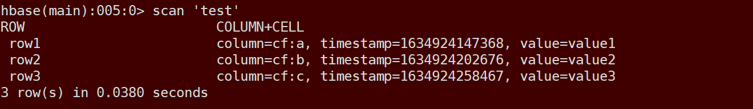

7. Get a single row of data.

To get a single row of data at a time, use the get command. For example, to get the row1 information.

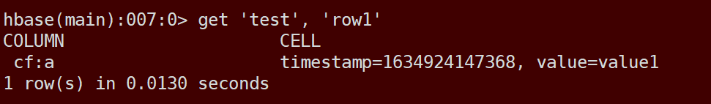

8. Disable a table.

If you want to delete a table or change its settings, as well as in some other situations, you need to disable the table first, using the disable command. You can re-enable it using

the enable command.

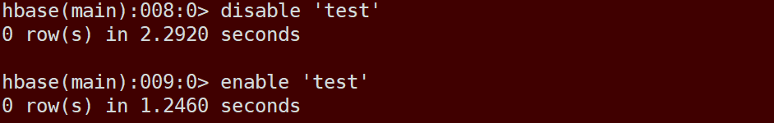

Disable the table again if you tested the enable command above:

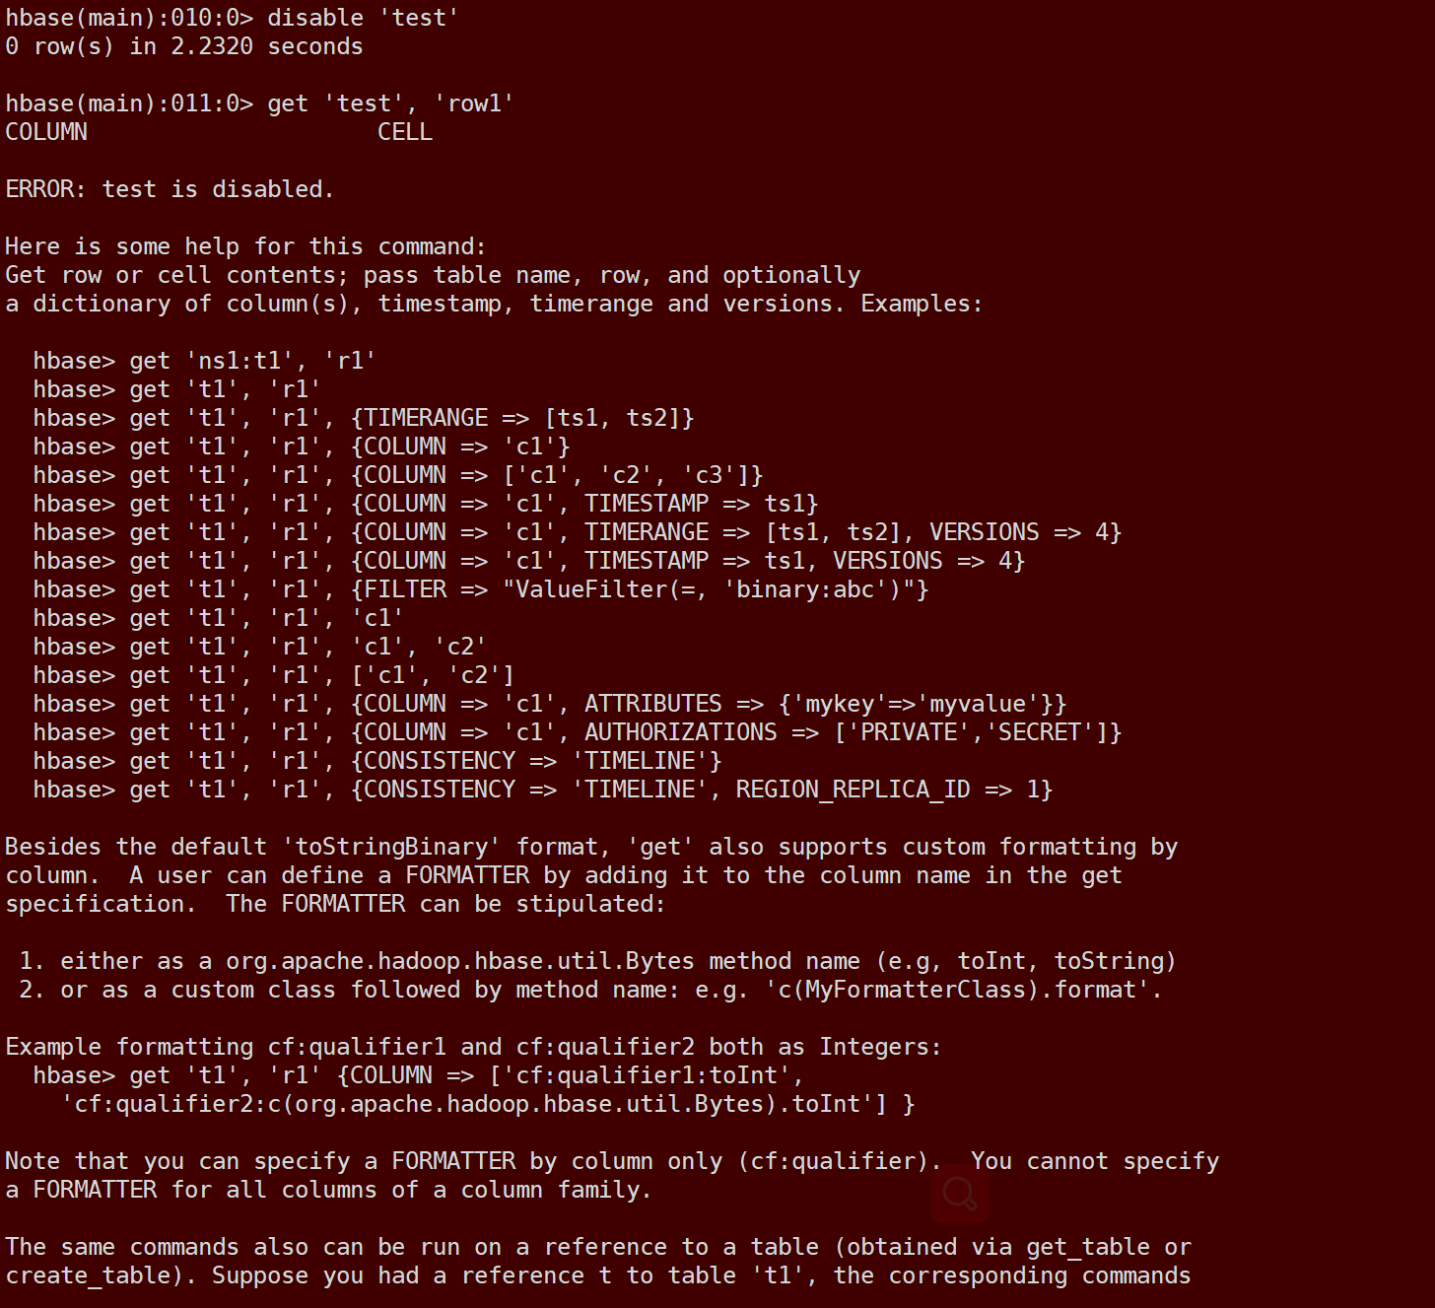

You can find that if you disabled this a table, you can not do any commands to this table or it will get some errors.

9. Drop the table.

To drop (delete) a table, use the drop command.

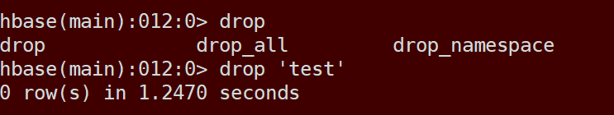

Then you cannot find this table by such command as scan and describe.

10. Exit the HBase Shell.

To exit the HBase Shell and disconnect from your cluster, use the quit command. HBase is still running in the background.

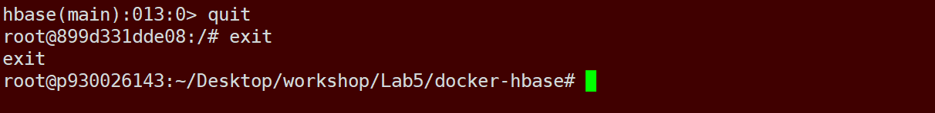

**Step 5： Run Hbase container again**

First, you need to start the HBase container again. Or, do step 3 again to create another container. This time, you need to create a hbase table to save the following data. You can name this table as Mytable, for example:

|  |  |  |  |  |  |  |
| --- | --- | --- | --- | --- | --- | --- |
|  | Home | | Office | | Social | |
| Key | First | Last | Phone | Email | Phone | Email |
| 101 | Florian | Krepsbach | 555-1212 | florian@wobegon.org | 666-1212 | fk@phc.com |
| 102 | Marilyn | Tollerud | 555-1213 |  | 666-1213 |  |
| 103 | Pastor | Inqvist |  |  | 555-1214 | inqvist@wels.org |

This table has three column families, and three row keys.

1. Create three table and define their .



(‘Mytable’ is the table name, ‘Home’, ‘Office’, ‘Social’ are ColumnFamily)

1. Add the information into the table.

For First row:

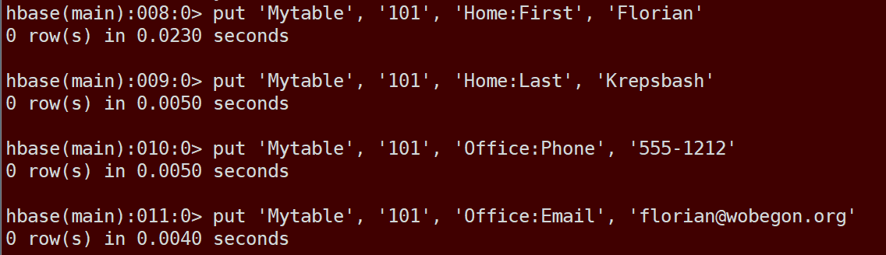

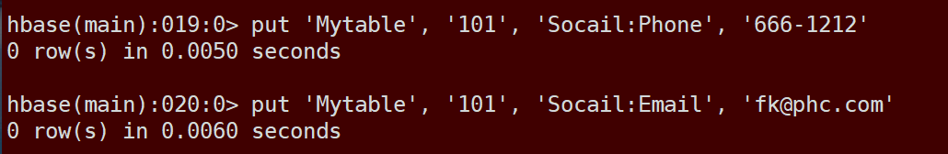

(‘101’ is row key; ‘First’ and ‘Last’ are column name of the ‘Home’ column family, ‘Phone’ and ‘Email’ are column name of the ‘Office’ column family, ‘Phone’ and ‘Email’ are column name of the ‘Social’ column family, and the last element is the value you want to input)

For second row:

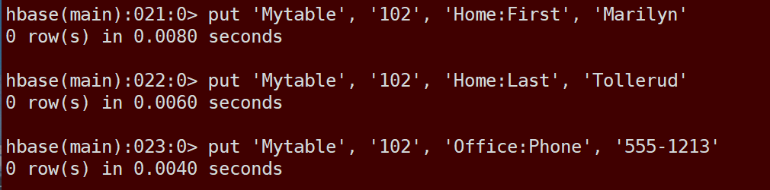



(‘102’ is row key; ‘First’ and ‘Last’ are column name of the ‘Home’ column family, ‘Phone’ and ‘Email’ are column name of the ‘Office’ column family, ‘Phone’ and ‘Email’ are column name of the ‘Social’ column family, and the last element is the value you want to input)

For third row:

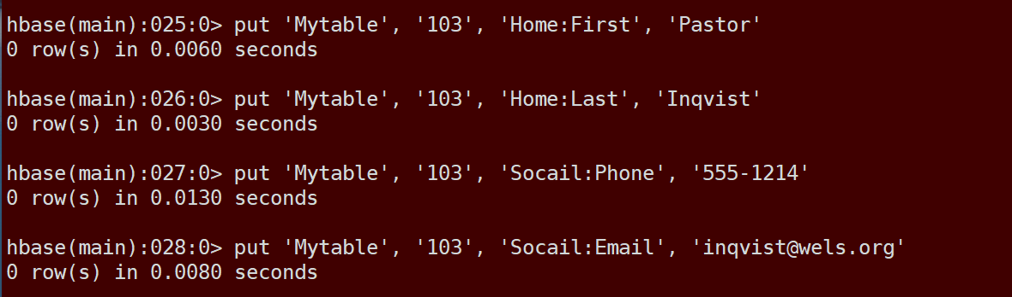

(‘103’ is row key; ‘First’ and ‘Last’ are column name of the ‘Home’ column family, ‘Phone’ and ‘Email’ are column name of the ‘Office’ column family, ‘Phone’ and ‘Email’ are column name of the ‘Social’ column family, and the last element is the value you want to input)

1. Check the result.

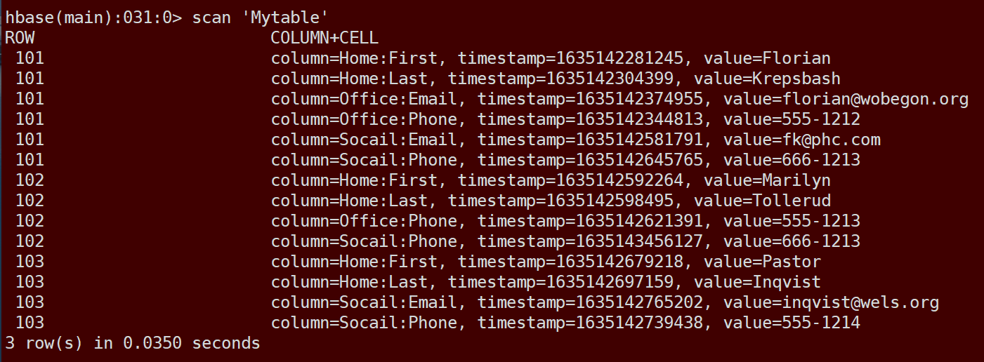

1. Exit the HBase Shell

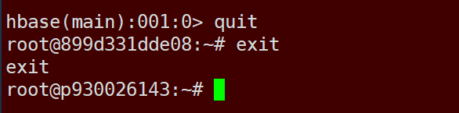

Finally, you finish the all task from this lab.